Process Flow :- FTP

Step 1:

Please select upload file view status option in FTP process menu.
Please mention no of files you want to upload and remark.

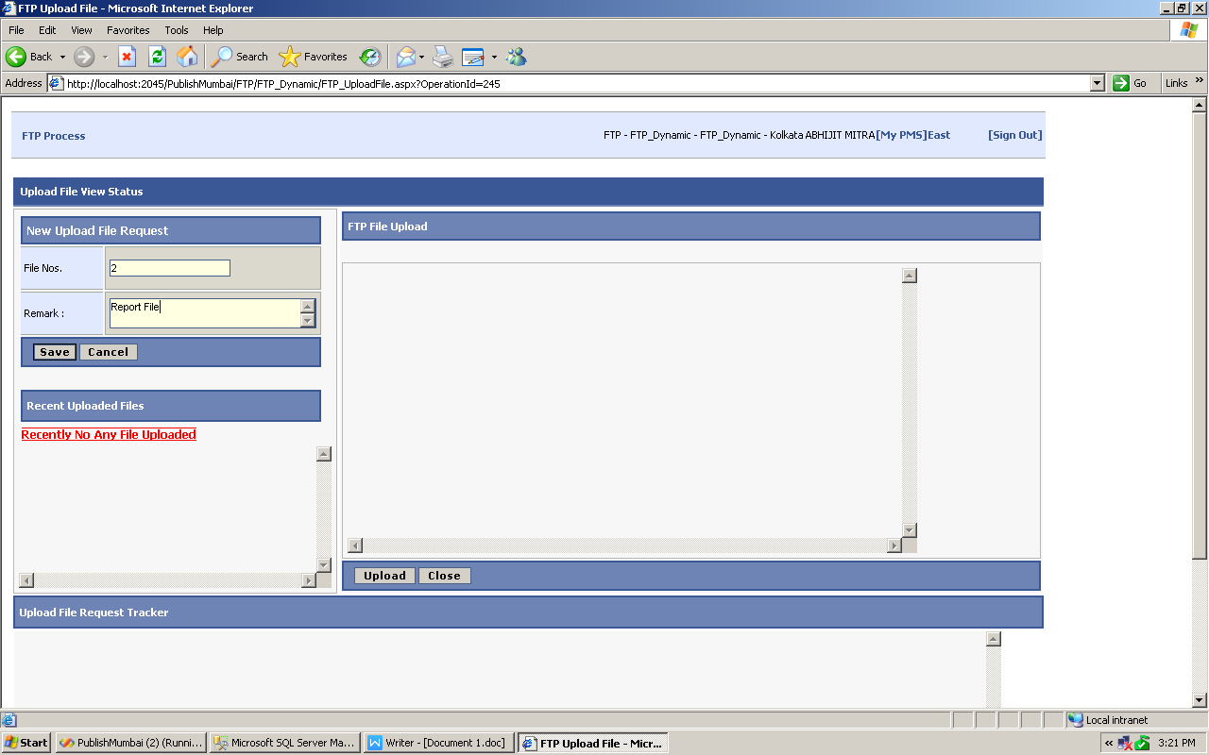

Step 2:
After clicking on save upload controls will get visible as per the no of files mentioned in file nos field.
Content expire date is system generated and non editable field.
Uploaded file will be available on the FTP for 3 days from the date of upload and same will be automatically removed from the FTP after 3 days.

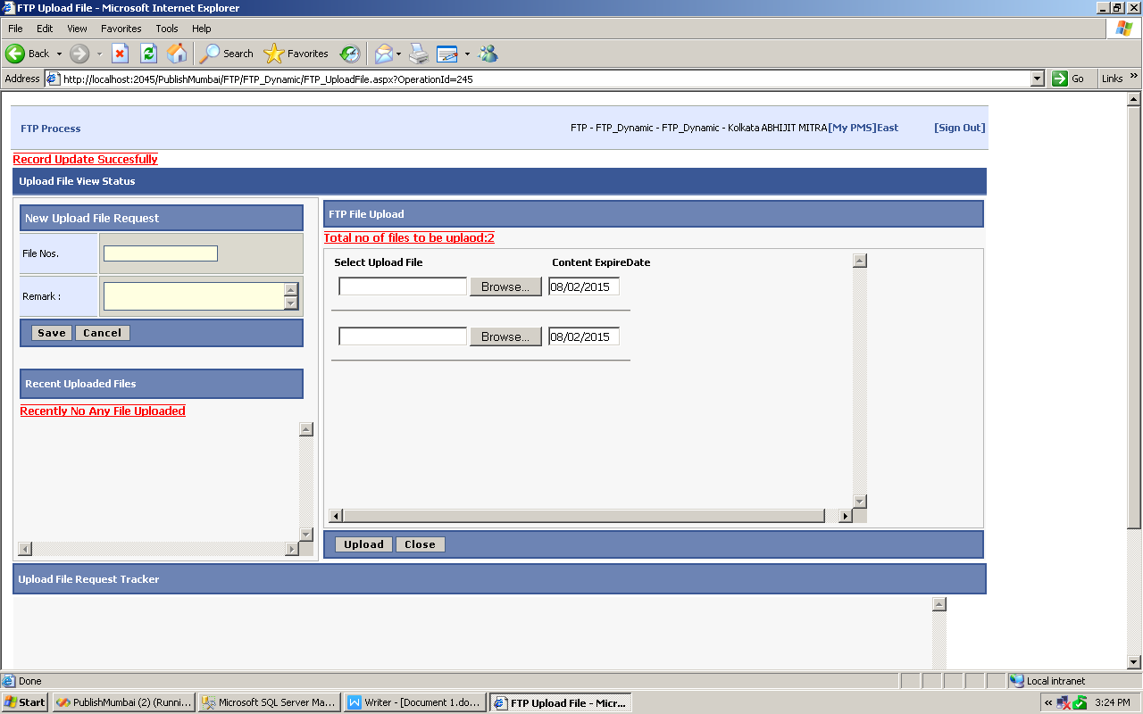

Step 3:

Please select files in each upload control.
Don’t use same or only one upload control to upload the multiple file’s else file will get overwrite.

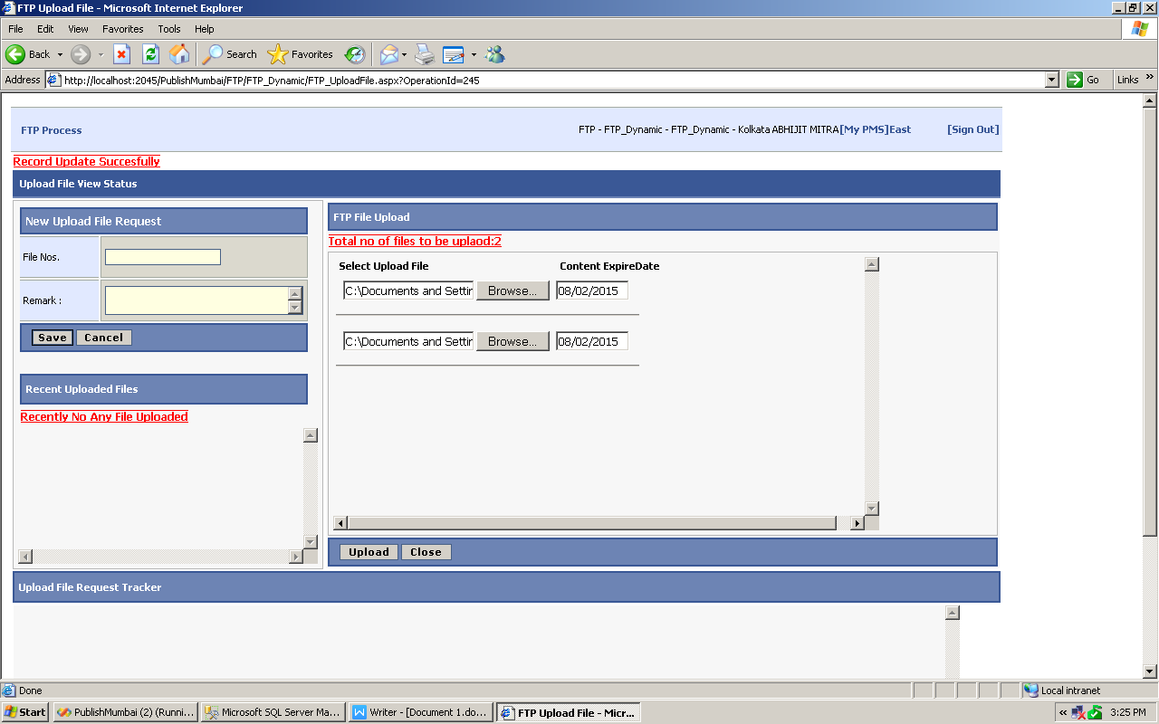

Step 4:
File View page.
Enter the date range.
It Will display All uploaded Files.

Select Share option to send file to Particular user.

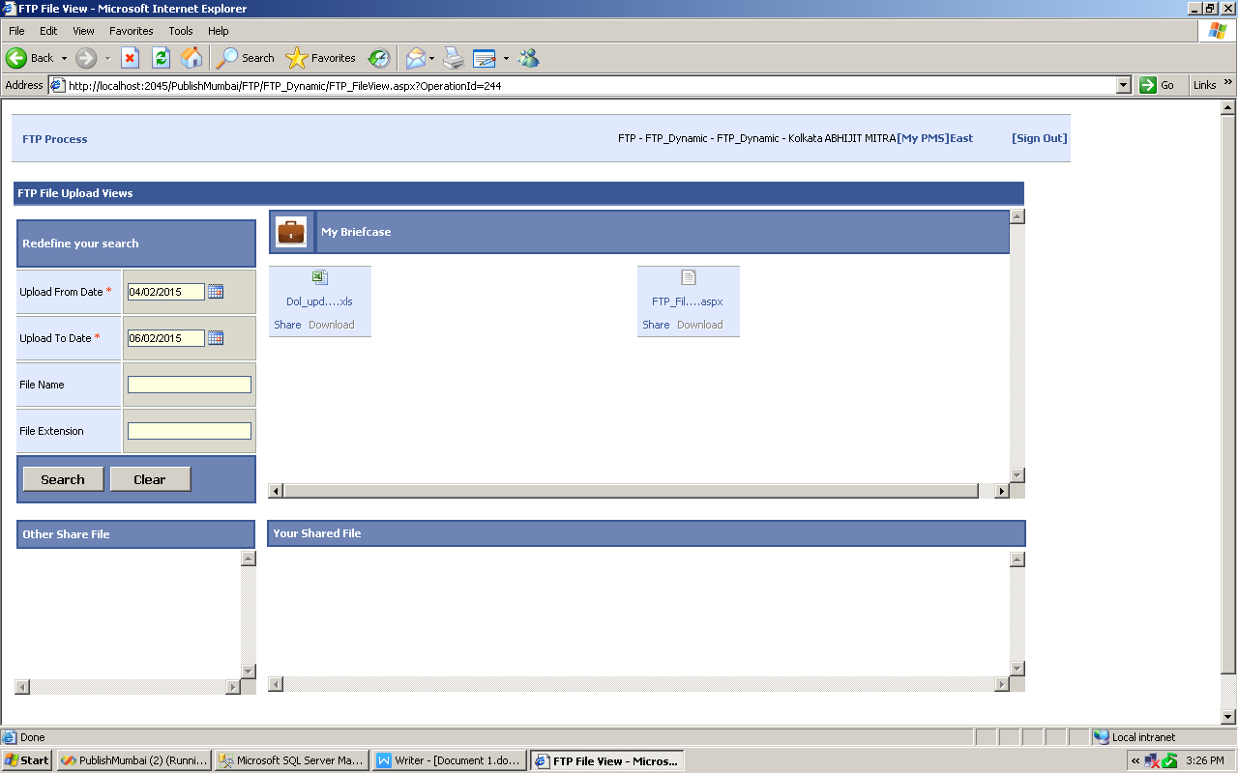

Step 5:

After click on Share link ,
It Display one more page which contain list of user.
Add particular user and click on Save.
After click on Save that file send to selected user at same time one notification mail also generated.
That mail also send to select user automatically.

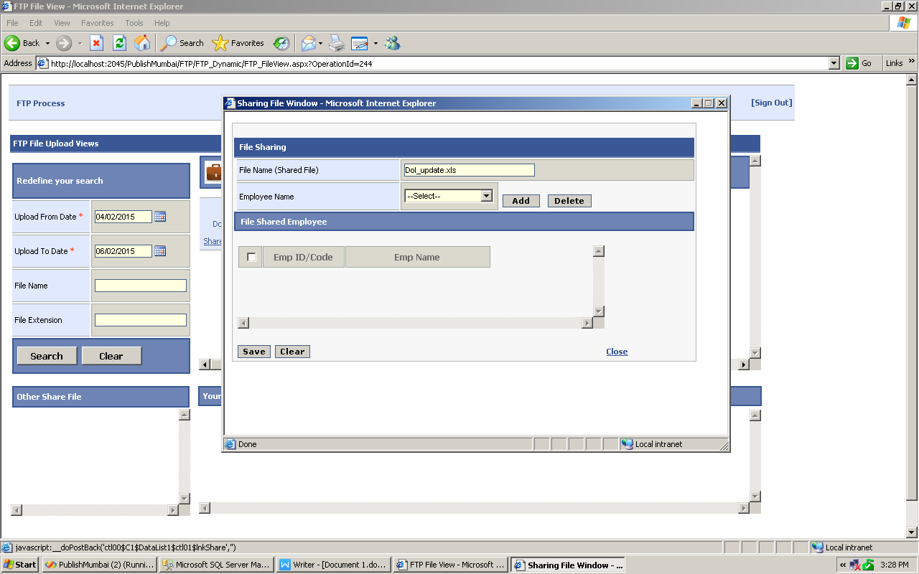

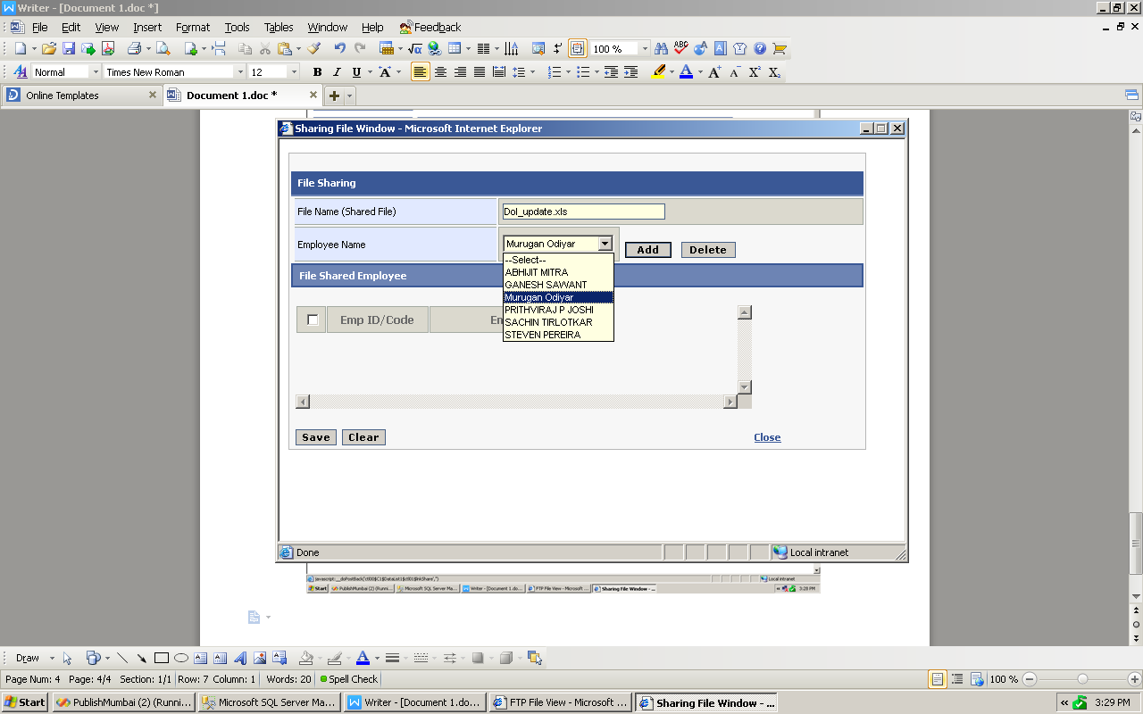

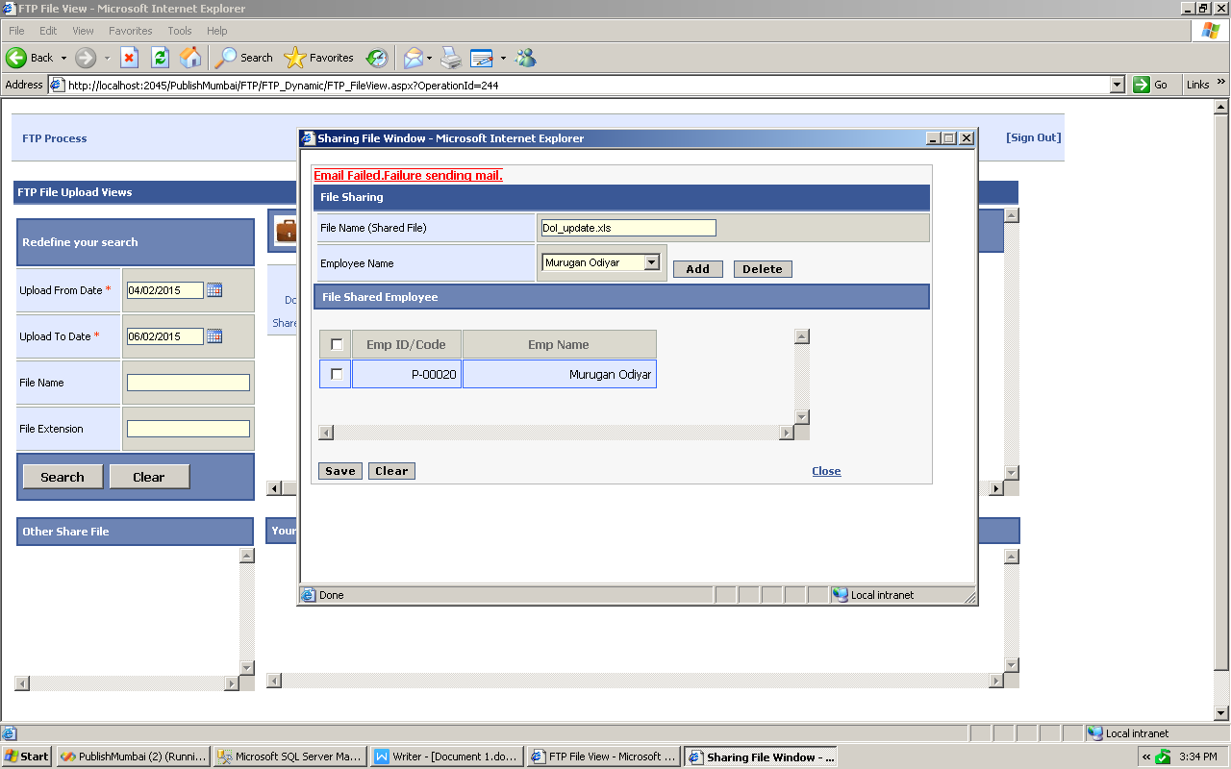

Step:9
Login with That particular user.
Click on FTP File View
User will get File with Download option in Other Share File tray.

